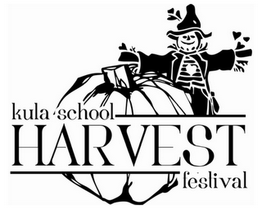
Kula Elementary School
25th Annual Harvest Fest
November 23, 2013

SILENT AUCTION DONATION FORM

Please include this completed form with your donation.

Mahalo for your support!
We couldn’t support our PE and arts programs without you.

Company Name: _______________________________________________________

Address: _____________________________________________________________

Contact Person: _______________________________________________________

Phone Number: _________________ Email: _______________________________

Description:

Value: ___________

Please select one of the following delivery options:
_____Gift Certificate is enclosed (mail to: Kula Elementary School PTA, Harvest Festival Silent Auction, 5000 Kula Highway, Kula, HI 96790)
___Item will be delivered to Kula Elementary School Office
_____Other:

To arrange a pick-up of your donation please email us at kulaPTA@gmail.com.

Kula Elementary School PTA is a 501(c)(3) nonprofit organization so your donations are tax deductible to the extent allowed by law. Federal Tax ID no. 99-0260369.

Have questions or need additional information?
Please email us at kulaPTA@gmail.com

www.kulaPTA.org
Kula Elementary School PTA * 5000 Kula Hwy, Kula, Hawaii 96790 * 808.878.7610

